**Lab Manual- Container Based App Deployment using Docker**

**Prepared for**:

**Date:** 18th Nov 2018

**Prepared by:** Aditi Shrivastava

Document Name: Lab Manual

**Document Number** SysOpsLab411

**Contributor:**

Table of Contents

1 OBJECTIVE 3

2 PRE-REQUISISTE 3

3 What is Docker and How it is different from Virtual Machine 3

4 What is Docker Container ? 3

5 Setup Up Docker 4

5.1 **Create a Docker Account** 4

6 Connect to Docker Playground 7

7 Pull Images , Create Container , Install App in Container and Create the Image from Container and Push to Docker Repo 10

# OBJECTIVE

Deploying your software becomes a lot easier after Docker where you don’t have to worry about missing a system configuration or a prerequisite. In This Lab will cover the basics of running, starting, stopping, and removing Docker containers.

* Create an Account in Docker HUB
* Install the Docker Tool Box on windows
* Use Docker Playground for Labs
* Perform the Basic Management

# PRE-REQUISISTE

* Accounts in Azure
* A local Computer with 4 CPU, 16 GB RAM, 200 GB disk space

# What is Docker and How it is different from Virtual Machine

The main difference between them is that Docker is an **isolated process** that runs in your native OS while the virtual machine is a**complete isolated OS** that runs on top of your host OS which takes more time to load. So, Docker has benefits over virtual machines such as:

* Loading speed
* Small hardware resources required, unlike virtual machines.
* Running multiple Docker containers at the same time on the same OS.
* You can modify your container and deploy it or give the Docker file definition to a friend to start working on the same environment.

Actually, Docker is not a replacement for virtual machines, it comes to solve specific problems.

Suppose that your application needs 3 or more services which run on different operating systems so instead of running 3 virtual machines on the same host, you can run 3 containers smoothly on the same host. Sounds great!

# What is Docker Container ?

Containers offer a logical packaging mechanism in which applications can be abstracted from the environment in which they actually run. This decoupling allows container-based applications to be deployed easily and consistently, regardless of whether the target environment is a private data center, the public cloud, or even a developer’s personal laptop. This gives developers the ability to create predictable environments that are isolated from rest of the applications and can be run anywhere.

# Setup Up Docker

## **Create a Docker Account**

***Steps 1:*** Open the below URL to sign up the docker

<https://hub.docker.com/>

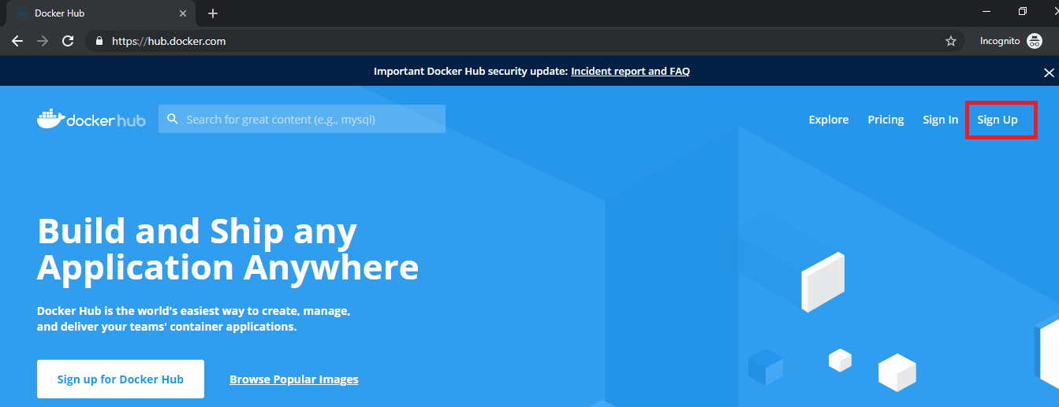

***Steps 2:*** Follow the Process of Signup as shown below

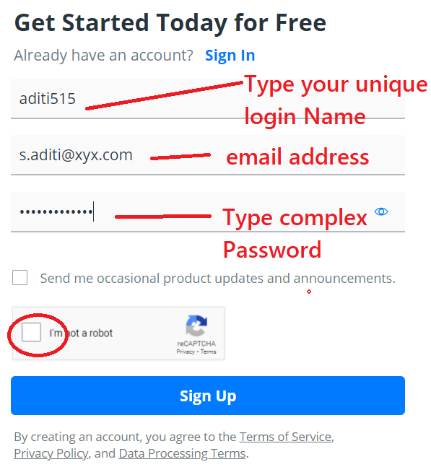

***Steps 3:*** Once you click signup you will present with screen similar to below Select free plan

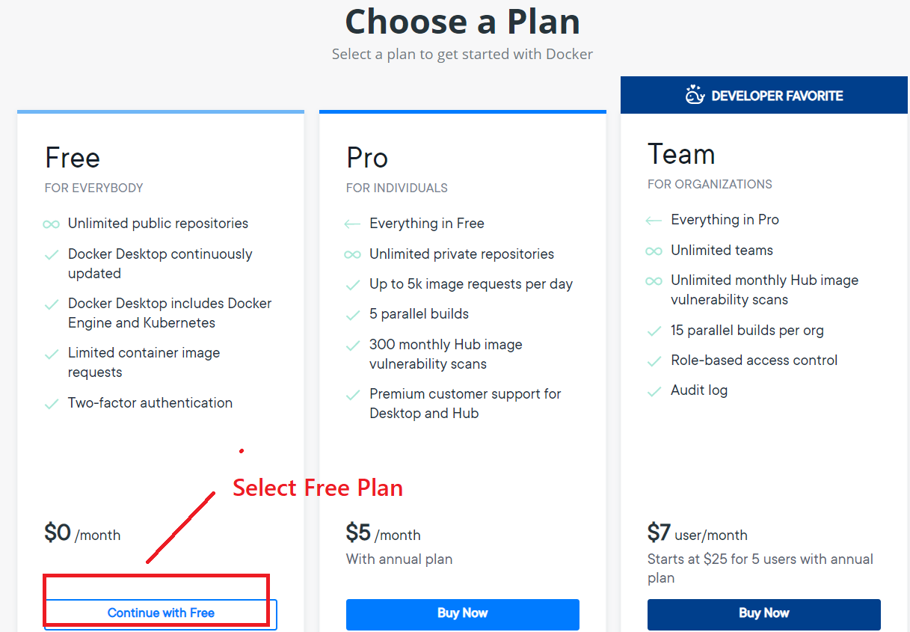

***Steps 4:*** Next Screen is to verify the email , go to your email and verify

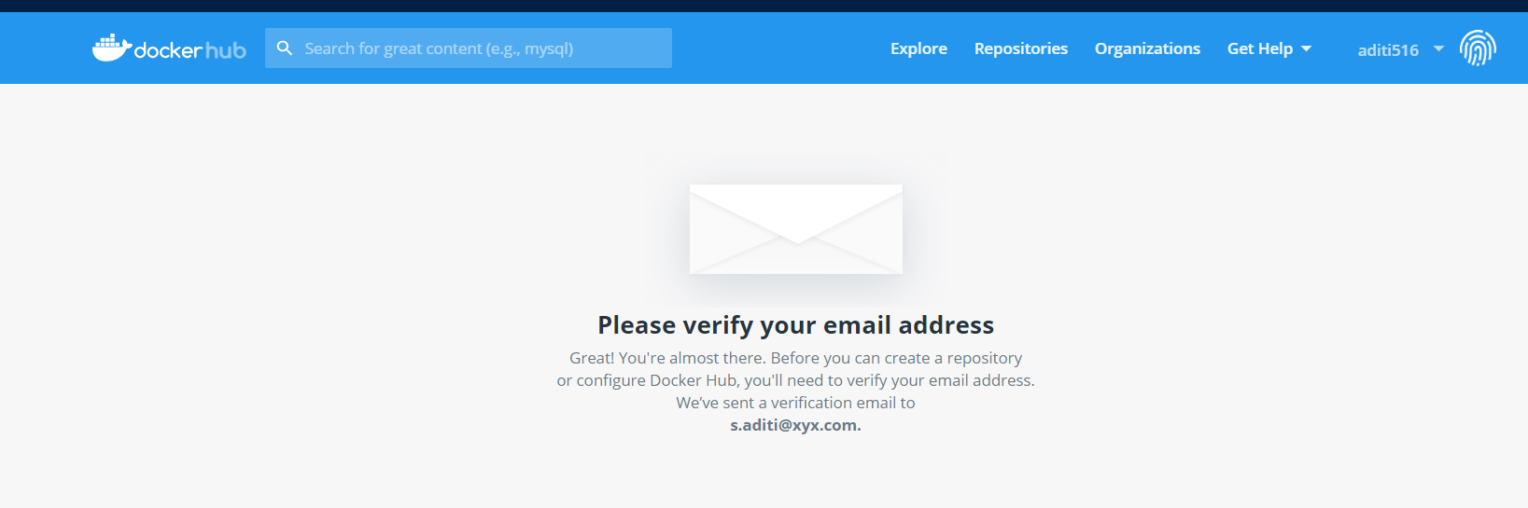

***Steps 5:*** Once you verify the email, you will present the screen to create a Repository. Type **Repositories name** / **description** and **Scope** (Public /Private) and click **Create**

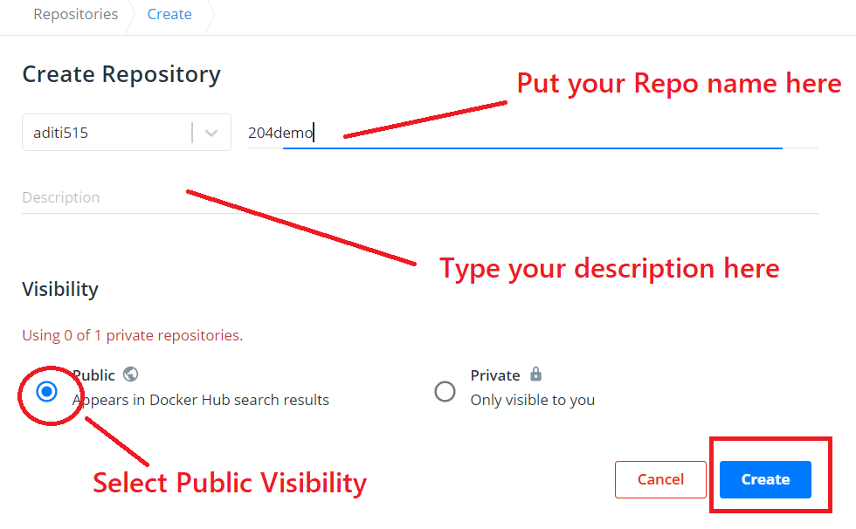

***Steps 7:*** Now your Repository should be available as shown in below

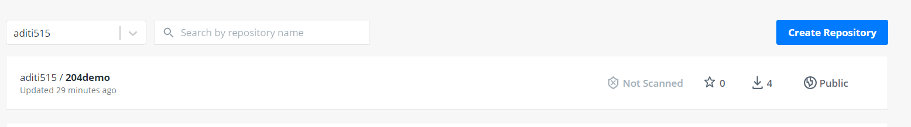

# Connect to Docker Playground

Playground provides a personalised sandboxed environment for you to learn and explore Docker.

***Steps 1:*** Open the Below URL in browser

<https://labs.play-with-docker.com/>

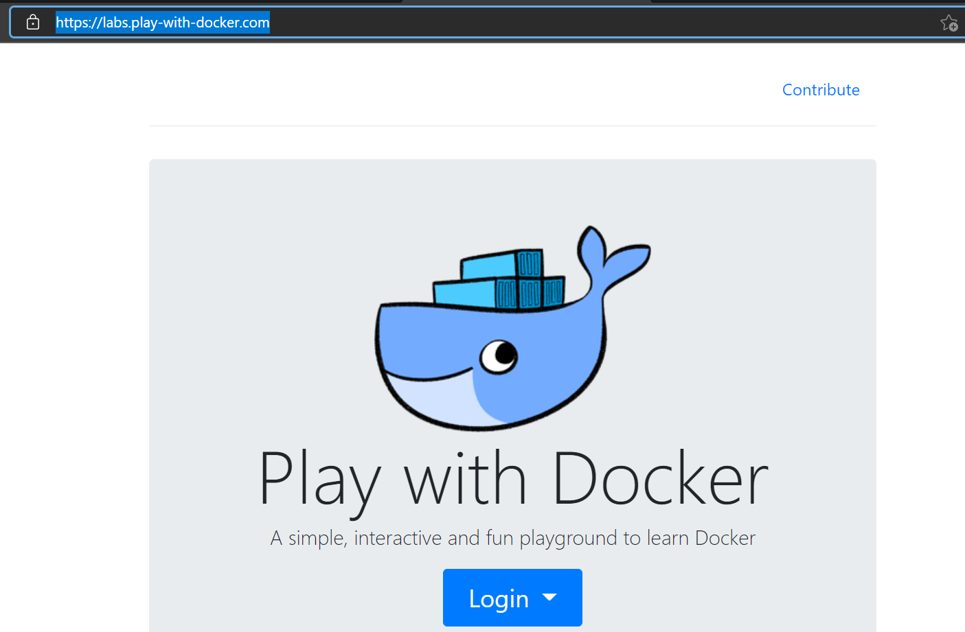

***Steps 2:*** Click the Login Button and select Docker

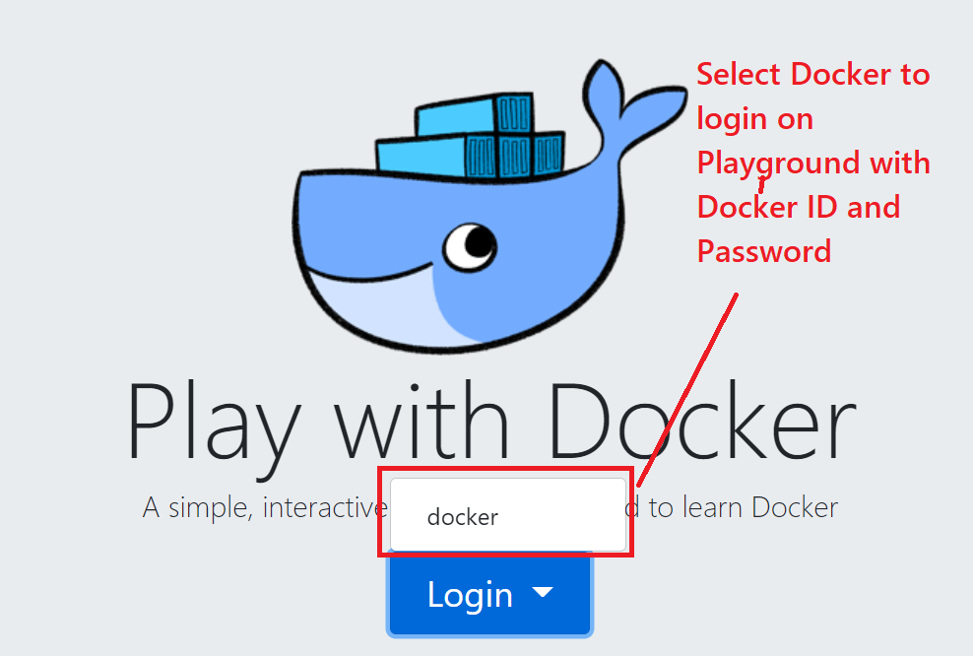

***Steps 3:*** Use your login and password you use to create Docker ID and click sign-in

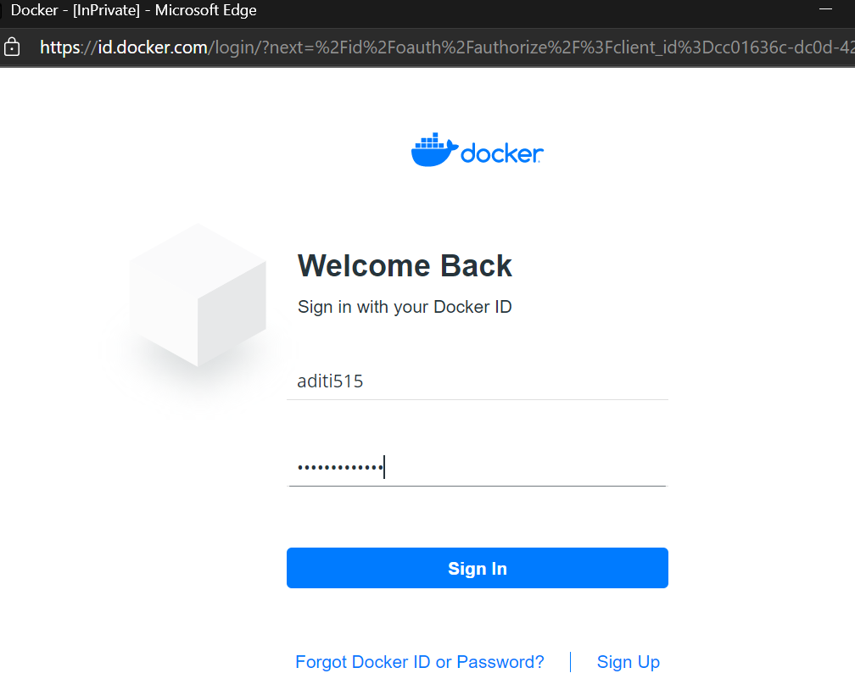

***Steps 4:*** Now Click Start to Launch the Docker Playground

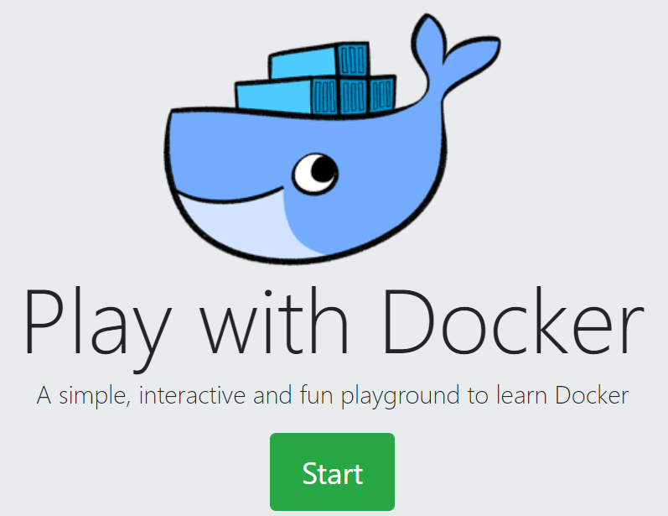

***Steps 5:*** On Left side of Panel there is Add New Instance

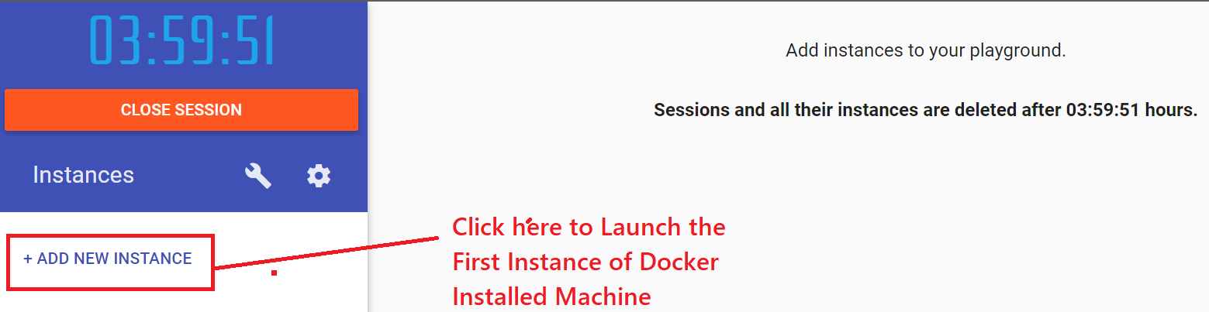

***Steps 6:*** Now new Black and white screen appear. Click inside and press **ALT + Enter.** It will launch the console in Full screen.

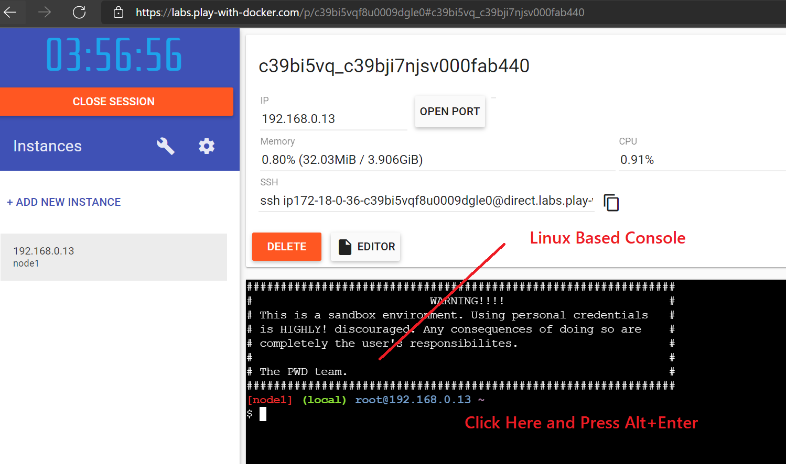

***Steps 7:*** Now Your console launch in full screen .If you want to increase the font Size just press CTRL and + .

***Steps 8:*** Now Type below command as below to check the version

docker --version

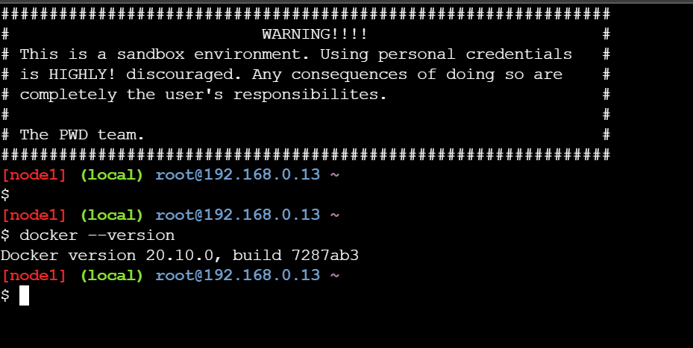

Now you are ready to play with all docker command

# Pull Images , Create Container , Install App in Container and Create the Image from Container and Push to Docker Repo

docker images

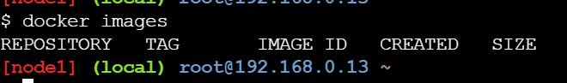

docker search oracle

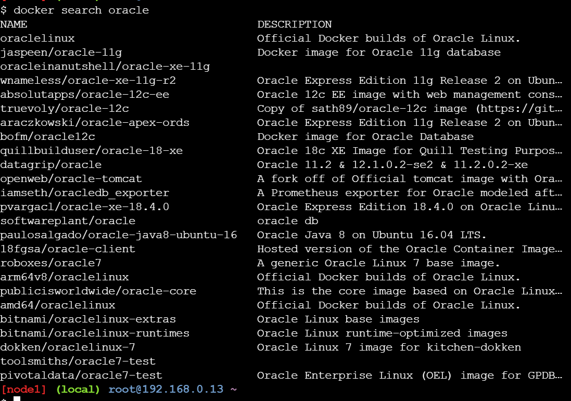

docker pull ubuntu

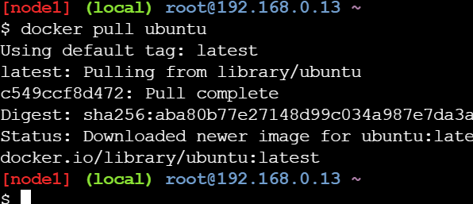

docker images

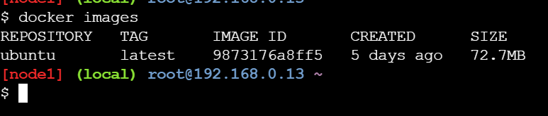

docker run -it –name myubuntu ubuntu

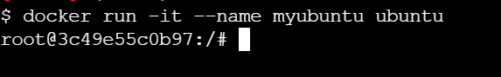

ls

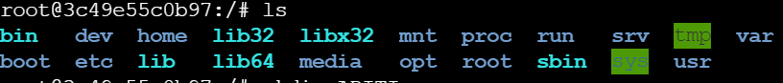

mkdir ADITI

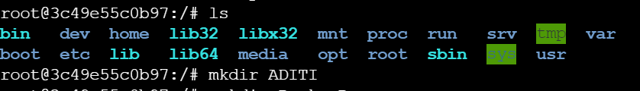

mkdir Docker-Demo



ls -l

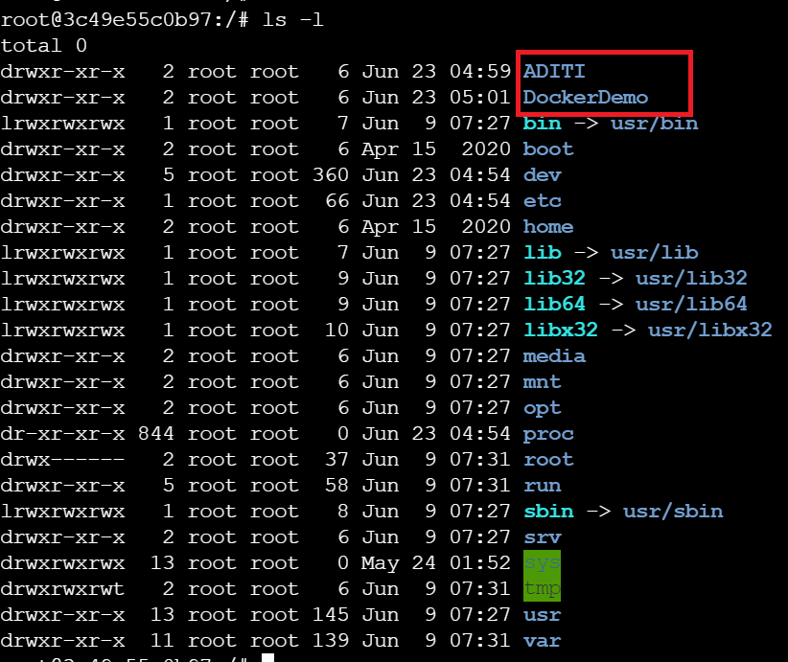

apt-get update -y

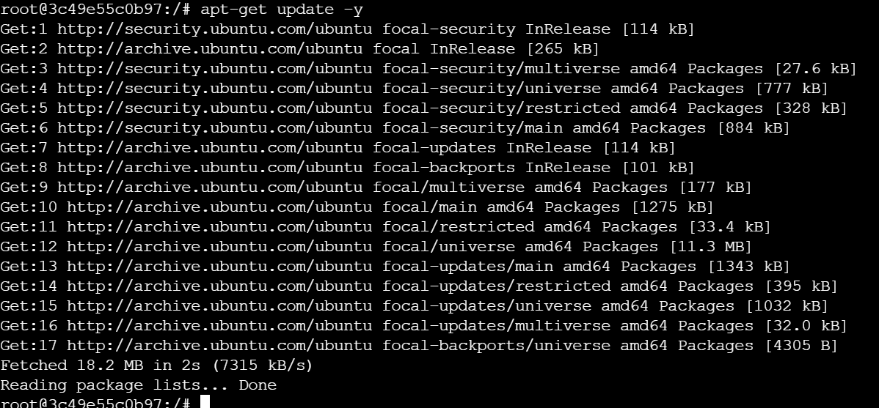

apt-get install figlet

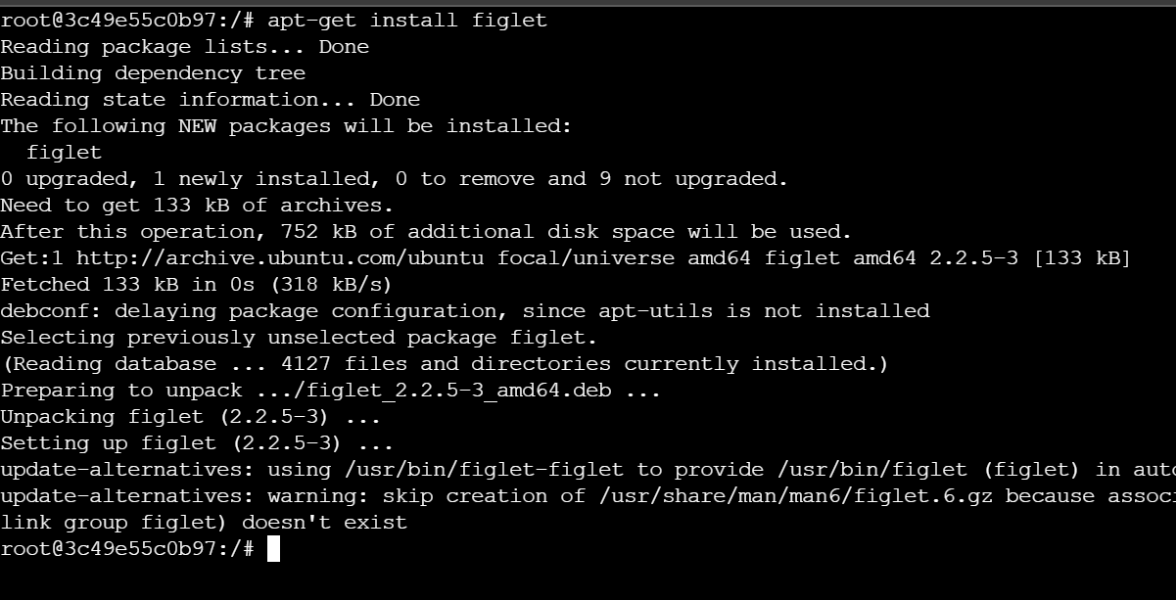

figlet Aditi

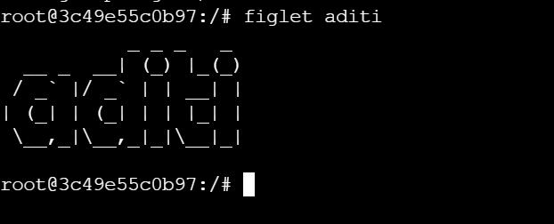

exit

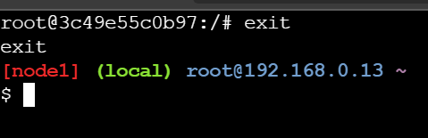

docker ps -a

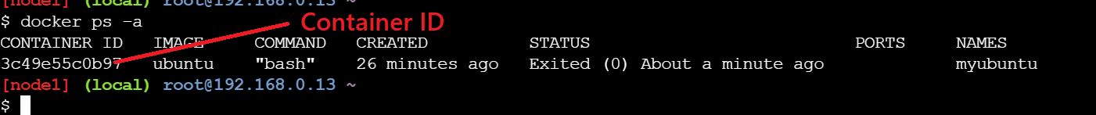

docker commit 3c49e55c0b97 aditi515/204demo:fig

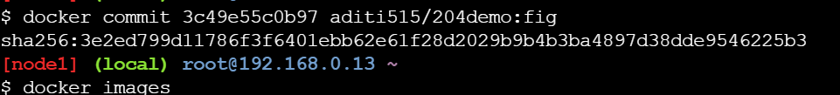

docker images

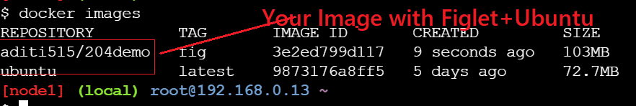

docker login

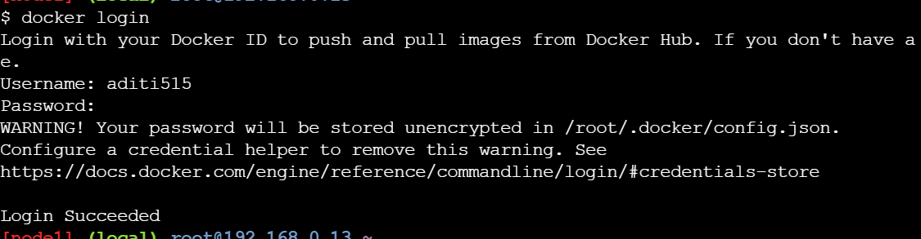

docker psuh aditi515/204demo:fig

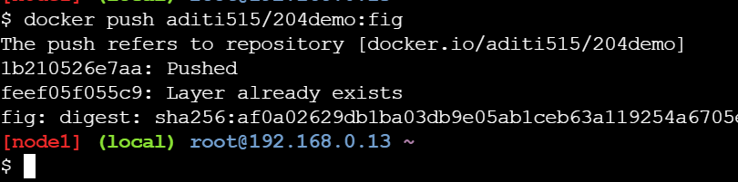

Now you can go to Docker Hub and Check you will have your own customer Image which contain **Ubuntu OS + Figlet App**

